

Nokia 1209

Description
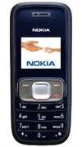
With a premium designer body of durable material an antislip backing and the ability to display more colors onscreen the Nokia 1209 is a stylish affordable package of simple but practical features

STORE PRICE: Rs 1,346 /-
ONLINE PRICE: Rs 1,201 /-

Brand : Nokia
Model Name : 1209
Released Year : 2008
Phone Memory : No
External Memory : No
Colors : Blue
Form : Bar
Dimensions : 102 x 44.1 x 17.5 mm
Weight : 79.9 g

